Cloud Network Architecture
Network Security analysis

Team 6: rootshell

Contents
1 Cloud Network - Threat Analysis 3
1.1 Introduction 3
1.1.1 Types of Cloud Networks and VPCs 3
1.1.2 Key elements related to Cloud Network Security 4
1.1.3 Security Considerations in typical Cloud Networks 4
1.1.3.1 The Design consideration, Vulnerabilities, threats etc 4
1.1.3.2 Analysing threats in a multilayer Single cloud Network 6
2 Cloud Network Architecture Review 8
2.1 Architecture Overview & Topology 8
2.2 Security Boundaries: Cloud-Native DMZ Analysis 9
2.3 Traffic Flow & Egress Analysis 9
2.3.1 NAT Gateway Implementation 10
2.3.2 Security Controls and Risk Mitigation 10
3 Vulnerability Identification Report 11
3.1 Assessment Scope 11
3.2 Core Network Vulnerabilities 11
3.3 Compliance Risk Analysis (FinTech Context) 12
3.4 Lateral Movement Attack Path 12
3.5 Risk Scoring Model 12
3.6 Critical Risks (Prioritized) 12
3.7 Technical Exploitation Depth 13
3.8 Monitoring Gaps 13
3.9 Mitigation Strategy 13
4 Best Practice Comparison 13
4.2 Gap Analysis Against Industry Standards 14
4.3 Security Benchmarks (CIS & NIST) 14
5 Threat Scenario Analysis 15
5.1 Security Considerations of concerned Network Architecture 15
5.1.1 Security threats 15
5.1.2 Criticality and Cost Optimization 17
5.1.3 Security threats arising from delivery models 18
5.1.4 Real Life examples of Security incidences for a Single VPC. 20
6 Improvement Recommendations 20
6.1 Modernize Management: Replace Bastions with AWS SSM 20
6.2 Advanced Egress Control: FQDN Filtering 21
6.3 Minimize Public Exposure: Deploy VPC Endpoints 21
6.4 Granular Micro-segmentation: Identity-Based SGs 21
6.5 Shift to Automated Governance (AIOps) 21
6.6 Database Tier Hardening: RDS Proxy & IAM Auth 21
7 Executive Summary 22
7.1 Overview and Context 22
7.2 Current Architecture Assessment 22
7.3 Critical Vulnerabilities and Gaps 22
7.4 Strategic Recommendations 23
8 References: 23

Cloud Network - Threat Analysis

Introduction
Cloud network architecture represents a fundamental shift from traditional on-premises infrastructure, introducing new paradigms in security, scalability, and operational efficiency. This section examines the architectural foundations of cloud-native networking, comparing modern Virtual Private Cloud (VPC) implementations with traditional perimeter-based approaches. Through analysis of tier separation, traffic flow patterns, and security controls, we establish the framework for understanding contemporary cloud network security.
The primary difference between cloud networks and traditional networks lies in how the infrastructure is how they are created/configured, managed, scaled, and therefore secured.
Traditional or the older way of providing networking solution is by means of providing physical hardware (racks, cables, and manual configuration), while cloud networks are Software-Defined (SDN) Networks, replacing the hardware layer of the traditional set up into virtualized services.
Another concept within Cloud Network is of VPC- A VPC or Virtual Private Cloud is a private, isolated network environment created within a public cloud (like AWS, Azure, or Google Cloud). Think of it as a "private slice" of a shared public cloud infrastructure.
While the physical hardware of the Public Cloud provider is shared with other customers (multi-tenancy), the individual customer’s VPC is logically isolated using virtual network functions, ensuring your data and traffic remain private.
This set up therefore demands a different security perspective.
While the traditional networks rely on edge specific protection such as Firewalls, the Cloud network do compartmentalization- “Micro-segmentation” using concept called “Security Groups” that follow the resource rather than port.
Additionally, expansion of the traditional networks are tough- with physical arrangement is needed, while Cloud networks are quite scalable and elastic therefore easy but then the expansion needs to be considered with due considerations while expanding which may get overlooked.

Types of Cloud Networks and VPCs
Cloud networks are broadly categorized into Public, Private, Hybrid, and Multi Cloud models, while VPC (Virtual Private Cloud) networks are isolated virtual networks within cloud providers like AWS or Google Cloud, offering subnets, route tables, gateways, and security controls. Below are authoritative sources with direct links.

Types of Cloud Networks
Public Cloud – Services delivered over the internet by providers like AWS, Azure, or Google Cloud.
Private Cloud – Dedicated infrastructure for one organization, offering more control and security.
Hybrid Cloud – Combines public and private cloud resources for flexibility and scalability.
Multi Cloud – Uses multiple cloud providers simultaneously to avoid vendor lock in and improve resilience.

Types of VPCs
A Virtual Private Cloud (VPC) is a logically isolated virtual network within a cloud provider. Different VPC network types are defined by how subnets, gateways, and connectivity are configured:
Public Subnet – Directly connected to the internet via an Internet Gateway; used for load balancers, bastion hosts, NAT gateways.
Private Subnet – No direct internet access; resources here use private IPs and rely on NAT gateways for outbound traffic.
Hybrid Connectivity VPCs – Connect on premises networks to cloud VPCs via VPN tunnels or Direct Connect/Interconnect.
Shared VPCs (Google Cloud) – Multiple projects share a common VPC network for centralized management.

Key elements related to Cloud Network Security
Due to complete virtualization of the network there are some key areas of the VPCs need to be paid some special attention. Following are (some of) the key areas related to the security perspectives:

VPC Design
VPC Design is the process of architecting a logically isolated virtual network in the cloud. A well-designed VPC ensures scalability, security, and high availability.
It involves CIDR block planning, subnet segmentation (public/private), routing tables, gateways, and security controls.

Security Groups
These act as a virtual firewall for instances (e.g., EC2). They are stateful, meaning if an inbound request is allowed, the outbound response is automatically permitted. They control inbound and outbound traffic for EC2 instances or other resources.

Network ACLs
The Network Access Control Lists are stateless firewalls applied at the subnet level. They allow or deny traffic explicitly, requiring rules for both inbound and outbound flows.

Transit gateways
A network hub used to interconnect multiple VPCs and on-premises networks. It simplifies networking by acting as a central router, replacing complex "mesh" peering configuration (and enables hub-and-spoke architecture).

Security Considerations in typical Cloud Networks

The Design consideration, Vulnerabilities, threats etc.
The different kind Cloud Networks pose different needs from design point view, have different challenges in terms of vulnerabilities and threats. Designing a cloud network requires balancing control, cost, and scalability while addressing the unique security risks inherent in each deployment model.
- Public Cloud: Most exposed due to shared infrastructure; requires strong IAM and encryption.
- Private Cloud: Offers control but vulnerable to insider misuse; zerotrust and audits are critical.-trust and audits are critical.
- Hybrid Cloud: Complexity introduces risks; visibility and secure connectivity are priorities.
- Multi-Cloud: Expands attack surface; unified governance and monitoring are essential.
Following is an overview of the typical design considerations, vulnerabilities threats in different kind of Cloud Networks.
Cloud Network Type | Design Considerations | Vulnerabilities | Threats
Public Cloud | Shared Responsibility/ Infrastructure – Multi tenant environment- Resource pooling;  Global availability Elasticity & Scalability;. | Misconfigured S3/storage buckets;  weak identities,  Insecure APIs;  data exposure,  Lack of visibility into provider infrastructure. | Account hijacking; DDoS attacks; Insider threats, Data breaches (for e.g. via credential theft);  API exploits. Compliance violations
Private Cloud | Dedicated Infrastructure;  High Control/ Customization; CAPEX heavy;  Data sovereignty. | Single point of failure; Outdated/Unpatched legacy hardware;  Weak Access control;  Outdated Patches;  Insider Misuse and Shadow IT within internal units. | Malicious insiders;  Unauthorized access;  Data leakage;  Compliance Gaps  Resource exhaustion; Ransomware moving laterally;  Physical site breaches.
Hybrid Cloud | Secure Interconnects (VPN/Direct Link); Integration of On premises and Public/private cloud;  Policy consistency; Cloud Bursting capabilities. | Inter-cloud data exposure; Inconsistent security policies;  Insecure VPN;  Visibility Gaps  Complex logging/audit trails across environments. | Lateral movement from on-prem to cloud;  Identity sync/federation exploits;  Token theft;  Data interception;  Misconfigured connections;  Third Party risks.
Multi-Cloud | Vendor lock-in avoidance- work load distrubution;  Interoperability; Diverse compliance management. | Fragmented visibility; Management complexity; Overlapping or conflicting security tools, Misconfiguration | Data sprawl; Compliance drift; Increased attack surface due to multiple cloud providers.

Analysing threats in a multilayer Single cloud Network
The network architecture type 3/multi-layer Single Cloud network, is perhaps with least security challenges as compared to complex, Hub and Spoke or Hybrid models.
And yet its threat scenario evaluation requires a structured approach that looks at each layer (Web/Public, Application/Private, Data/Restricted) and the interactions between them. The goal is to identify vulnerabilities, attack vectors, and mitigation strategies across tiers.
To analyse threat scenarios for a Multi-Tier Architecture within a single Virtual Private Cloud (VPC), one must look at how data flows between layers (Web, Application, and Database) and where the "trust boundaries" are.
The most effective methods to analyse these threats involve a combination of structural modelling and "outside-in" testing.
Following are some of the key methods which are typically used in analysing this kind of network.
- STRIDE Threat Modelling
Developed by Microsoft, STRIDE is the gold standard for breaking down what can go wrong in a segmented network.
- Spoofing: Can a compromised App server spoof the identity of an admin?
- Tampering: Can data be altered as it moves between tiers?
- Repudiation: Are logs sufficient to prove who accessed the Database?
- Information Disclosure: Is sensitive data unencrypted in the VPC?
- Denial of Service: Is there a bottleneck in the NAT Gateway?
- Attack Path Mapping (Lateral Movement Analysis) and/ Traffic Flow & Segmentation Analysis/Layered Threat Modelling
In a single VPC, the biggest threat is Lateral Movement. If an attacker compromises a Public Subnet (Web Tier), you must analyze the path to the Private Subnet (DB Tier).
- Security Group Analysis: Check for "Any/Any" rules that allow broad traffic between tiers. Map north south traffic (internet ↔ web tier) and east west traffic (between app and data tiers).
- Identity-Based Paths: Check if the IAM role attached to the Web server has permissions to read from the Database S3 buckets or RDS directly. Ensure segmentation with security groups and NACLs to prevent lateral movement
- Break down the architecture into Web Tier, Application Tier, and Data Tier and Identify threats specific to each:
- Web Tier (Public Subnets) → DDoS, SQL injection, cross site scripting, exposed load balancers.
- Application Tier (Private Subnets) → privilege escalation, insecure APIs, lateral movement.
- Data Tier (Restricted Subnets) → unauthorized access, data exfiltration, replication misconfigurations.
- Attack Surface Enumeration/ Automated Configuration Auditing
Manual analysis is prone to error. Use tools to find "Misconfiguration Vulnerabilities" which account for the majority of cloud breaches.
- Use CSPM (Cloud Security Posture Management) tools to scan for misconfigurations. Manual analysis is prone to error. Use tools to find "Misconfiguration Vulnerabilities" which account for the majority of cloud breaches.
- Check for:
  - Open ports in security groups.
  - Overly permissive IAM roles.
  - Unencrypted data in transit or at rest and publicly accessible snapshots
- Simulation & Penetration Testing
- Conduct red team exercises simulating attacks:
- Compromised web server → pivot to app tier.
- Misconfigured NAT gateway → data exfiltration.
- Use MITRE ATT&CK framework to model adversary techniques.
- Monitoring & Logging
- Enable VPC Flow Logs to monitor traffic anomalies.
- Integrate with SIEM tools for real time detection.
- Apply CloudTrail for API activity tracking.

Cloud Network Architecture Review

Architecture Overview & Topology
The proposed cloud network architecture implements a robust 3-Tier Virtual Private Cloud (VPC) design. This architecture prioritizes defense-in-depth security, strict separation of duties, and high availability by spanning resources across two Availability Zones.
The network topology is segmented into three distinct logical tiers, ensuring that traffic flows securely from the internet to the web layer, then to the application logic, and finally to the data store, with no direct access permitted between the internet and the data tier.
High-Level Network Diagram:
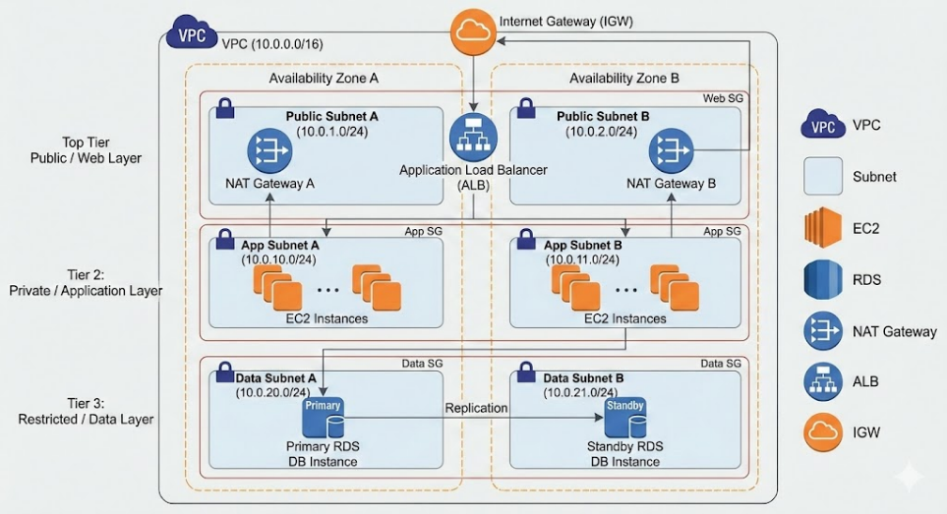
Data Flow Diagram: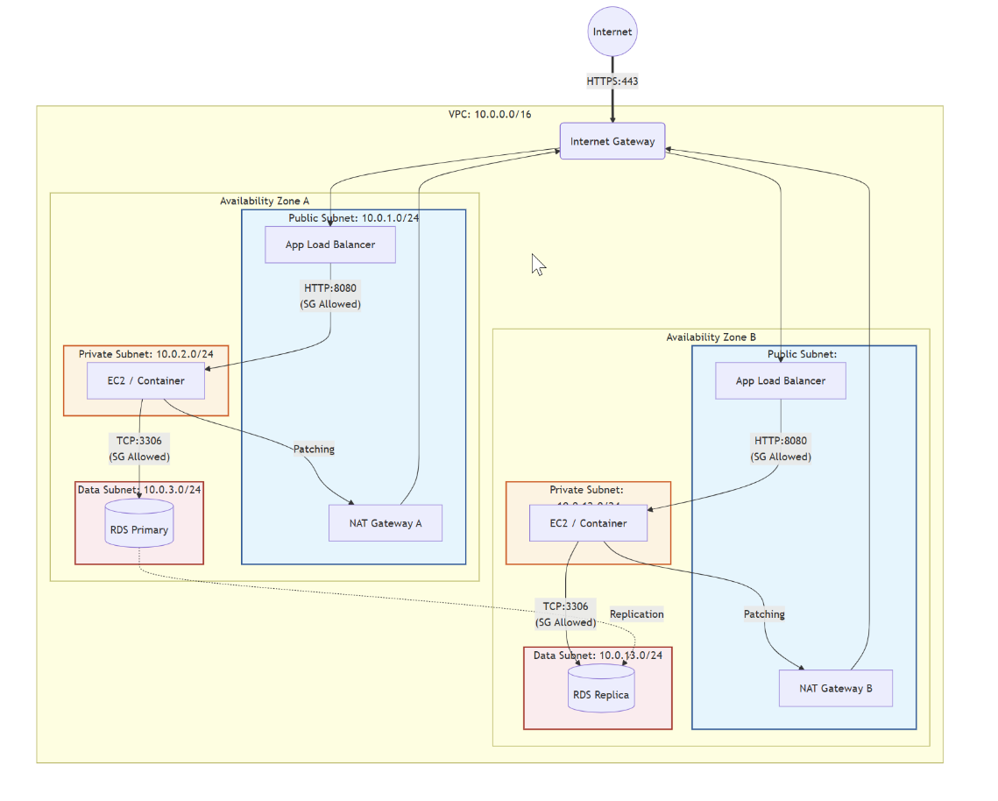
Tier Definitions & Connectivity: The following table details the purpose and connectivity profile for each tier within the architecture:
Tier | Type | Purpose | Connectivity Profile
Web Tier | Public | Hosts Application Load Balancers (ALB) and Bastion Hosts/VPN endpoints. | Inbound: Internet (via IGW).  Outbound: Internet.
App Tier | Private | Hosts application servers, container workloads (EKS/ECS), or backend logic. | Inbound: Web Tier only.  Outbound: Internet via NAT Gateway (strictly for patches/APIs).
Data Tier | Private | Hosts RDS databases, ElastiCache, or Redshift clusters. | Inbound: App Tier only.  Outbound: None (or restricted S3 endpoints).

Security Boundaries: Cloud-Native DMZ Analysis
Unlike traditional on-premise networks that rely on physical "Edge DMZs" and hardware firewalls, this architecture utilizes a Cloud-Native Implementation of security boundaries. This approach shifts the focus from physical isolation to logical separation and micro-segmentation.
Comparison of Security Boundaries:
- Isolation Model:
- Traditional: Relies on physical network segments or VLANs enforced by core switches.
- Cloud-Native: Uses Logical Separation via subnets defined by IP CIDR blocks and Route Tables. While this allows for rapid deployment, it requires strict route table management to prevent "leaks" that could accidentally expose private subnets to the internet.
- Ingress Filtering (Layer 3/4):
- Traditional: Utilizes high-capacity perimeter hardware firewalls.
- Cloud-Native: Implements a dual-layer defense using Network ACLs (NACLs) at the subnet boundary (stateless) and Security Groups at the instance boundary (stateful). This provides "Defense-in-Depth," where Security Groups act as a distributed firewall for every network interface (ENI).
- Micro-segmentation:
- Traditional: Complex to implement, often requiring internal firewalls for every server group.
- Cloud-Native: Security Groups natively support Zero Trust principles. For example, "Server A" and "Server B" in the same subnet can be blocked from communicating unless explicitly allowed, reducing the blast radius of a potential compromise.

Traffic Flow & Egress Analysis
The architecture dictates strict traffic flow rules to maintain security integrity, particularly regarding outbound (egress) traffic from private resources.
Egress Architecture (NAT Gateway): To allow private instances (App Tier) to download essential updates without exposing them to the internet, the architecture employs NAT Gateways located in the Public Subnets.
- Routing Logic: Traffic originates from the Private Instance, routes through the Private Route Table to the NAT Gateway, and finally exits via the Internet Gateway. The NAT Gateway performs Source NAT (SNAT), replacing the private IP with its Elastic IP.
- Inbound Protection: The NAT Gateway is stateful; it allows return traffic only for connections initiated from inside the VPC. Any unsolicited connection attempts from the internet are automatically dropped, effectively shielding private instances from direct inbound scans.
Design Justification (Gateway vs. Instance): The decision to use a managed NAT Gateway rather than a NAT Instance is based on operational resilience and security:
- Availability: NAT Gateways are fully managed and highly available, scaling automatically to 100 Gbps.
- Security Posture: While NAT Instances allow for custom hardening (e.g., iptables), they represent an additional attack surface that the user must patch and manage. A compromised NAT Instance gives an attacker control over the egress point. The managed NAT Gateway operates as a "black box," making it significantly harder to compromise directly.

NAT Gateway Implementation
- NAT Gateway Configuration Steps
- Allocation: Create a NAT Gateway in the Public Subnet. It requires an Elastic IP (EIP) to communicate with the internet.
- Route Table Modification (Private): Update the Route Table associated with the Private Subnet (App Tier). Add a route for 0.0.0.0/0 (all internet-bound traffic) pointing to the nat-gateway-id.
- Route Table Modification (Public): Ensure the Public Subnet Route Table has a route for 0.0.0.0/0 pointing to the Internet Gateway (IGW). The NAT Gateway resides here and uses this path to exit the VPC.
- Security Groups (App Tier): Configure the App Tier Security Group to allow outbound traffic to 0.0.0.0/0 (or specific IPs) on ports required for updates (e.g., TCP 80/443).
- Validation: Traffic originates from the Private Instance -> Private Route Table -> NAT Gateway (Public Subnet) -> Internet Gateway -> Internet. The NAT Gateway performs Source NAT (SNAT), replacing the private IP with its EIP.
- Inbound Traffic Blocking
- Stateful Nature: The NAT Gateway automatically tracks the state of outbound connections. It allows return traffic only for connections initiated from inside the VPC.
- Unsolicited Inbound Drop: Any unsolicited traffic connection attempt from the internet to the NAT Gateway's Elastic IP is dropped by default, as there is no internal mapping for it. This effectively shields private instances from direct inbound scans.

Security Controls and Risk Mitigation
- Data Exfiltration Risks (Unmonitored NAT)
- Unrestricted Egress: Standard NAT Gateways allow all outbound traffic to valid destinations. A compromised instance can connect to a Command & Control (C2) server or upload data to an external storage bucket.
- Lack of Filtering: NAT Gateways operate at Layer 3/4. They do not inspect payloads or filter by domain name (FQDN). Malware can use standard ports (443) to hide malicious traffic.
- Recommendation: Implement VPC Flow Logs to monitor traffic metadata. For stricter control, use AWS Network Firewall or a transparent proxy (e.g., Squid) in conjunction with the NAT Gateway to filter outbound traffic by FQDN (e.g., allow *.ubuntu.com, block everything else).
- Comparison: NAT Gateway vs. NAT Instance
- Availability & Management:
- NAT Gateway: Fully managed, highly available service. AWS handles redundancy and scaling. No patching required.
- NAT Instance: A standard EC2 instance running NAT software. The user is responsible for OS patching, scaling, and handling failover (e.g., using scripts to remap routes if the instance dies).
- Security Posture:
- NAT Gateway: "Black box" security. Cannot install custom security agents or inspect traffic directly on the gateway. Harder for an attacker to compromise the gateway itself.
- NAT Instance: Can be hardened with custom iptables rules, DLP agents, or proxy software. However, it is an additional attack surface; if compromised, the attacker controls the egress point.
- Performance:
- NAT Gateway: Scales automatically to 100 Gbps.
- NAT Instance: limited by the instance type's network bandwidth.
- Recommendation: Use NAT Gateway for most production workloads due to reduced operational overhead and higher resilience. Use NAT Instances only if specific, cost-sensitive, low-throughput, or custom traffic inspection use cases (that cannot be met by other services) are required.

Vulnerability Identification Report

Assessment Scope
The network security assessment covered the following AWS VPC components and controls:
- VPC CIDR design, subnet tiering, and multi-AZ isolation
- Internet Gateway (IGW) exposure and routing controls
- Public, Application, and Data subnet segregation
- Security Group inbound and outbound rule enforcement
- NAT Gateway egress access and outbound traffic control
- Application Load Balancer (ALB) internet exposure
- EC2 instance network exposure and administrative access
- RDS network isolation and replication traffic protection
- Network logging, visibility, and alerting mechanisms

Core Network Vulnerabilities
Vulnerability | Risk | Business Impact
Flat trust between application and data subnets | High | Enables lateral movement to financial databases
Over-permissive Security Group inbound rules | High | Internet attackers gain access to internal tiers
Unrestricted outbound access via NAT Gateway | Medium | Enables data exfiltration and command-and-control
ALB exposing unnecessary ports or paths | High | Expands attack surface of web layer
Weak isolation between AZs | Medium | Increases blast radius during compromise
EC2 instances with public IPs | High | Direct exposure of compute workloads
Insufficient RDS subnet isolation | High | Unauthorized access to regulated financial data
Incomplete VPC flow logging | Medium | Delayed breach detection and investigation

Compliance Risk Analysis (FinTech Context)
Risk | Compliance Impact
Poor subnet tier segregation | Violates PCI DSS network segmentation requirements
Overexposed ALB and web layer | Breaches RBI perimeter security expectations
Weak Security Group controls | Fails ISO 27001 access restriction controls
Data subnet reachable from public tier | Expands PCI DSS scope unnecessarily
Missing network logs | Violates RBI audit trail and incident response mandates

Lateral Movement Attack Path
- Attacker compromises an internet-facing web EC2 via ALB
- Enumerates Security Groups and reachable subnets
- Moves laterally into application subnet
- Exploits overly trusted Security Group relationships
- Accesses RDS instances in data subnet
- Results in financial data theft or transaction manipulation
This demonstrates systemic risk caused by weak tier isolation.

Risk Scoring Model
Risk Rating | Category | Meaning
1 | Very Low | Minimal security or business impact
2 | Low | Limited operational impact
3 | Medium | Noticeable security or compliance risk
4 | High | Significant financial or regulatory exposure
5 | Critical | Severe impact requiring immediate action

Critical Risks (Prioritized)
Risk Name | Priority | Justification
Internet-exposed web tier | 1 | Primary attack vector to fintech workloads
Weak subnet segmentation | 2 | Enables rapid lateral movement to databases
Over-permissive Security Groups | 3 | Violates least-privilege and PCI DSS controls
Unrestricted NAT Gateway egress | 4 | Enables undetected data exfiltration
Insufficient network logging | 5 | Delays breach detection and regulatory reporting

Technical Exploitation Depth
- Internet scans discover ALB-exposed services
- Web tier compromise via vulnerable application
- Security Group trust abused for lateral movement
- Application tier compromise escalates privileges
- Database access achieved through internal routing
- Leads to fraud, ransomware, or financial data loss
This aligns with real-world cloud breach patterns.

Monitoring Gaps
Gap | Risk Impact
VPC Flow Logs disabled | East-west traffic invisible
ALB access logs missing | Web attack detection delayed
NAT Gateway traffic unmonitored | Data exfiltration unnoticed
RDS connection logs missing | Unauthorized access undetected
Logs not centralized | Ineffective incident response
Short log retention | Regulatory audit failures

Mitigation Strategy
Vulnerability | Mitigation
Weak subnet tier isolation | Enforce strict Public/App/Data separation
Over-permissive Security Groups | Apply least-privilege and periodic reviews
Public IPs on EC2 | Remove public IPs; access via ALB only
Unrestricted outbound traffic | Restrict NAT egress destinations
ALB overexposure | Limit listeners and paths
RDS reachable from app tier broadly | Restrict DB access to required instances
Missing flow logs | Enable VPC Flow Logs
Logs not sent to SIEM | Centralize logging and alerting

Best Practice Comparison
Designing a Virtual Private Cloud (VPC) requires a balance between scalability, performance, and rigorous security. Based on the 2026 industry standards, best practices can be divided into three core sections.
4.1 VPC Design Best Practices (2026 Standards)
Modern cloud architecture has shifted from "perimeter defense" to Zero Trust Networking.
- Logical Segmentation:
  - Tiered Subnetting: Use a minimum of three tiers (Public, Private, and Data) across at least two Availability Zones (AZs) for high availability.
  - Micro-segmentation: Implement granular security group rules at the resource level rather than relying solely on subnet-level Network ACLs.
- IP Address Planning: * Avoid the common pitfall of overlapping CIDR blocks with on-premises or other VPCs to prevent future routing conflicts during peering or VPN expansion.
- Connectivity Hubs: * Use a Transit Gateway or Cloud WAN for central routing in multi-VPC environments. This replaces complex mesh peering and simplifies traffic inspection.
- Edge Security: * Deploy NAT Gateways in public subnets to allow private instances to access the internet securely without exposing them to inbound traffic.

Gap Analysis Against Industry Standards
A "Gap Analysis" identifies where our design might fall short of the NIST Cloud Computing Framework or ISO/IEC 27017.
Feature | Current Common "Gap" | Industry Standard (2026)
Trust Model | Implicit trust within the VPC. | Zero Trust Architecture (ZTA); identity-based access.
Visibility | Log collection for debugging only. | Continuous Monitoring via VPC Flow Logs and AIOps for anomaly detection.
Traffic Flow | Direct internet access for backend. | Use of PrivateLink or VPC Endpoints to keep traffic on the provider's backbone.
Compliance | Periodic manual audits. | Automated Guardrails (Infrastructure as Code) that prevent non-compliant resource creation.

Security Benchmarks (CIS & NIST)
The Center for Internet Security (CIS) and NIST provide the gold standard for "hardening" your network.
- CIS Foundations Benchmark (v4.0.0/2026)
- Networking (Section 4): Ensure VPC Flow Logging is enabled for all VPCs.
- Default Security Groups: The default security group must restrict all inbound and outbound traffic (deny-all by default).
- Remote Access: Restrict SSH (port 22) and RDP (port 3389) from 0.0.0.0/0. Use "Bastion Hosts" or managed services like AWS Systems Manager Session Manager.
- NIST Cybersecurity Framework (CSF) for Networks
- Identify: Maintain an automated, real-time inventory of all VPC assets and CIDR ranges.
- Protect: Implement Encryption in Transit (TLS 1.3) even for internal traffic between subnets.
Detect: Use cloud-native threat detection (e.g., Amazon GuardDuty, Google Cloud IDS) to monitor for lateral movement or DNS tunneling.

Threat Scenario Analysis

Security Considerations of concerned Network Architecture
The network architecture considered in this article and in section “Network Architecture” is of type 3/multi-layer Single Cloud network.
Common threats in a three/multi tier architecture within a single cloud VPC include misconfigurations, insecure APIs, lateral movement between tiers, and unauthorized database access. Each tier (Web, Application, Data) has distinct risks that must be analyzed and mitigated.
Threat | Brief Explanation
Misconfigured Security Groups | Overly permissive rules can expose web servers or application instances to the internet, allowing attackers entry.
Compromised Application Tier | A single vulnerable application can allow attackers to pivot into deeper layers of the architecture.
Insecure APIs | Poorly secured APIs between web and app tiers can be exploited for injection or privilege escalation.
Lateral Movement | Attackers who gain access to one tier can move laterally into private subnets or data tiers if segmentation is weak.
Unauthorized Database Access | Weak IAM or unencrypted connections can expose sensitive data in the restricted/data tier.
Replication Misconfigurations | Improperly configured database replication across availability zones can lead to data leakage or corruption.
DDoS Attacks on Web Tier | Public endpoints and load balancers are vulnerable to denialofservice attacks if not protected by WAF or Shield.-of-service attacks if not protected by WAF or Shield.

Security threats
The particular security threats faced by the considered Single Cloud 3 layer network are can be represented by following image:
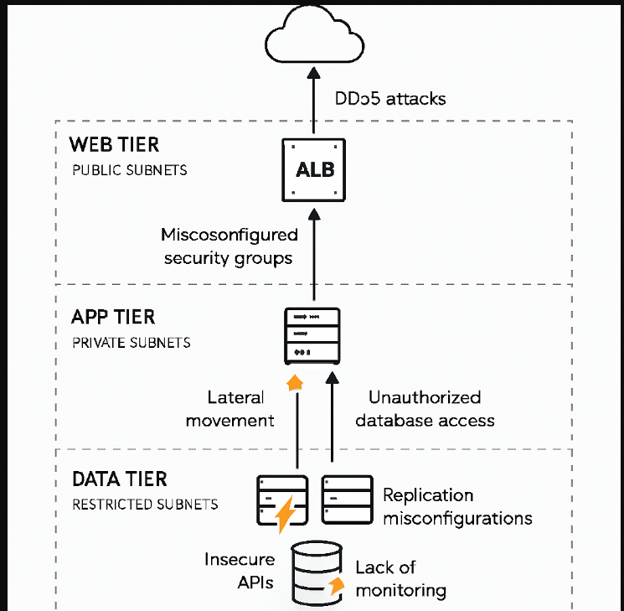
Security Threats in VPC Design
- 1 Misconfigured Route Tables and/or Accidental Public Exposure via Route Table Leaks
- Threat: Incorrect routing can accidentally expose private subnets to the internet, bypassing intended isolation. The architecture relies on Logical Separation using IP CIDR blocks and Route Tables rather than physical isolation. Mismanagement of these route tables could lead to "leaks" that accidentally expose private subnets (App or Data tiers) directly to the Internet Gateway.
- Impact: Data tier resources (databases) could be reachable from outside.
- Overly Permissive Security Groups
- Threat: Security groups act as stateful firewalls, but if configured with wide open rules (e.g., 0.0.0.0/0 inbound), attackers can exploit exposed services.
- Impact: Web tier ALBs or bastion hosts could be compromised, leading to entry into private tiers.
- Weak Network ACL Configurations
- Threat: NACLs are stateless and must explicitly allow/deny traffic. Misconfigured ACLs can either block legitimate traffic or allow malicious flows.
- Impact: Attackers could bypass subnet boundaries or exploit open ports.
- NAT Gateway Misuse or Targeting the NAT Gateway for Data Exfiltration
- Threat: NAT Gateways allow outbound traffic from private subnets. If not restricted, compromised app servers could exfiltrate sensitive data. The design uses a NAT Gateway in the Public Subnet to allow private App Tier instances to reach the internet for patches. If an App Tier instance is compromised, an attacker can use this existing egress path to exfiltrate sensitive data to an external serve
- Impact: Data leakage through unrestricted outbound connections.
- Lateral Movement Between Tiers or Lateral Movement via Compromised Web Tier
- Threat: If micro-segmentation is not enforced, attackers who compromise the web tier can move laterally into the app or data tiers. The Web Tier has inbound connectivity from the internet via the Internet Gateway. If an attacker compromises a resource in the Web Tier (such as an ALB or Bastion host), they could attempt to move laterally into the App Tier, as the App Tier is designed to accept inbound traffic from the Web Tier
- Impact: Escalation from public-facing servers to sensitive databases.
- Insufficient Monitoring
- Threat: Without VPC Flow Logs and CloudTrail, malicious activity (port scans, unauthorized API calls) may go undetected.
- Impact: Delayed detection of breaches and compliance violations.
- Single Layer of Stateful Defence:
While the architecture uses a "dual-layer defense" with NACLs and Security Groups, Security Groups act as the primary stateful firewall for every network interface. A single misconfiguration in a Security Group could bypass the micro-segmentation intended to isolate servers within the same subnet.
- Compromise of Management Access Points:
The Web Tier hosts Bastion Hosts or VPN endpoints for administrative access. These represent high-value targets; if compromised, they provide a direct "jumping point" into the private App and Data tiers, bypassing standard external traffic filters.
- Dependency on Managed Service Availability:
The architecture relies heavily on managed components like the NAT Gateway for operational resilience. While harder to compromise than a manual NAT instance, a service-level failure or a massive DDoS targeting the NAT Gateway's Elastic IP could sever the App Tier's ability to receive critical security patches.

Criticality and Cost Optimization
There are always cost benefit considerations while designing a system. Same is the case of Security measures – the criticality and cost impact. From this point of following may be useful while addressing the mitigation measures:

Criticality and Costs
🔥 Threat Severity vs 💰 Cost Optimization Priority
Threat Scenario | Severity | Cost Optimization Priority | Why It Matters
Misconfigured Security Groups | 🔴 High | ✅ High | Easy to fix with tight rules; no extra cost.
DDoS Attacks on Web Tier | 🔴 High | ⚠️ Medium | AWS Shield Standard is free; Advanced is costly.
Lateral Movement to App Tier | 🔴 High | ✅ High | Microsegmentation via SGs is low-cost and effective.
Insecure APIs | 🟠 Medium | ⚠️ Medium | API Gateway adds cost; IAM and throttling help.
NAT Gateway Misuse | 🟠 Medium | 🔼 High | NAT Gateway egress is expensive; monitor usage.
Unauthorized Database Access | 🔴 High | ✅ High | IAM and encryption are built-in; no extra spend.
Replication Misconfigurations | 🟡 Low | ⚠️ Low | Rare but impactful; periodic review suffices.
Lack of Monitoring | 🔴 High | 🔼 Medium | Enable logs selectively to reduce spend.

Optimization Strategy
• Focus first on high-severity, low-cost fixes: tighten security groups, enforce IAM, isolate tiers.
• Monitor NAT Gateway usage: consider NAT instances for low-volume traffic.
• Use built-in AWS tools: CloudTrail, IAM roles, encryption — all offer strong security without extra cost.
• Enable logging selectively: VPC Flow Logs only on critical subnets to reduce data ingestion costs.

Security threats arising from delivery models
Apart from the design of the VPC and setting up Security Groups or NACLs, one key consideration from security point of view is to be considered as what is the delivery model.
The delivery model of a cloud network—whether IaaS, PaaS, or SaaS—fundamentally redefines the "Shared Responsibility Model." This model dictates the division of security tasks between the cloud service provider (CSP) and the customer. As you move from IaaS toward SaaS, the provider manages more of the stack, but the customer's responsibility for data and identity remains constant.
Security Impact by Delivery Model
Delivery Model | Network Security Impact | Customer Responsibility | Provider Responsibility
IaaS (Infrastructure) | Maximum Control & Complexity. The customer builds the entire virtual network (VPCs, Subnets). | Firewall rules (SGs/NACLs), OS patching, VPNs, and internal routing. | Physical security, virtualization layer, and hardware.
PaaS (Platform) | Identity-Centric Security. The network perimeter is often managed by the provider; security relies on API permissions. | IAM policies, API security, and database access configurations. | Network isolation, OS hardening, and runtime environments.
SaaS (Software) | Data & Access Focus. The network is a "black box." Security is enforced at the user and data level. | MFA, user permissions, and data classification. | Entire network stack, application code, and infrastructure.

Detailed Security Analysis
1. IaaS: Software-Defined Perimeter Control
In an IaaS model (e.g., AWS VPC, Azure VNet), the customer is the "Network Architect." The primary security impact is the requirement for manual configuration of stateful and stateless firewalls.
- Risk: The most significant threat is misconfiguration. A single open port (e.g., RDP or SSH) or an overly broad Security Group rule can expose the entire internal network.
2. PaaS: Abstracted Networking
In PaaS (e.g., Google App Engine, Azure SQL), the provider handles the underlying network infrastructure. The security impact is a shift from "IP-based" security to "Identity-based" security.
- Benefit: The provider automatically patches the OS and manages network-level DDoS protection.
- Risk: "Identity is the new perimeter." If an attacker steals an API key or an IAM token, they can often access the service regardless of the network location unless VPC Service Controls are implemented.
3. SaaS: Perimeter-less Security
In SaaS (e.g., Microsoft 365, Salesforce), the customer has zero control over network routing or firewalling. Security is managed through Zero Trust principles.
- Impact: Since the network is managed by the provider, the customer must focus on Conditional Access (e.g., only allowing logins from specific IP ranges or compliant devices).
- Risk: Data exfiltration via compromised accounts is the primary threat, as the application is globally accessible over the public internet.

Real Life examples of Security incidences for a Single VPC.
Real-world incidents in single-cloud, three-tier VPC architectures often involve misconfigurations, insecure APIs, lateral movement, and database exposure. These cases show how weaknesses in one tier can cascade across the entire environment.

⚠️ Real-Life Case Examples (3-Tier Cloud VPC)
Tier | Incident Example | Brief Explanation
Web Tier (Public Subnets) | Capital One AWS Breach (2019) | A misconfigured Web Application Firewall (WAF) allowed an attacker to exploit SSRF (Server-Side Request Forgery) and access sensitive data from the public-facing tier.
App Tier (Private Subnets) | Tesla Kubernetes Console Exposure (2018) | Tesla left a Kubernetes admin console unsecured in a private subnet, enabling attackers to run cryptojacking workloads and pivot deeper into the app tier.
Data Tier (Restricted Subnets) | MongoDB Cloud Exposures (2017) | Thousands of misconfigured MongoDB instances in cloud VPCs were left open without authentication, leading to mass data theft and ransom demands.
Cross-Tier Movement | Verizon AWS S3 Leak (2017) | A contractor misconfigured S3 bucket permissions, allowing attackers to move laterally from app tier logs into sensitive customer data.

Improvement Recommendations
To optimize the network security of the 3-tier VPC architecture proposed, the following technical recommendations focus on transitioning from traditional perimeter-based security to a Zero Trust and automated governance model.
These suggestions specifically address the "Gaps" and "Threats" identified earlier, such as implicit trust, manual auditing, and potential data exfiltration via NAT Gateways.

Modernize Management: Replace Bastions with AWS SSM
The current architecture utilizes "Bastion Hosts" in the public tier for administrative access. These are high-value targets that require maintaining open inbound ports (SSH/22 or RDP/3389) .
- Optimization: Replace Bastion hosts with AWS Systems Manager (SSM) Session Manager.
- Technical Benefit: Session Manager allows shell access to EC2 instances in your App and Data tiers without requiring a public IP or any inbound Security Group rules. All traffic is tunneled through the SSM API, authenticated via IAM, and logged for auditing, effectively eliminating the "jumping point" threat mentioned previously.

Advanced Egress Control: FQDN Filtering
The standard NAT Gateways operate at Layer 3/4 and cannot filter by domain name, posing a risk for data exfiltration via common ports like 443 .
- Optimization: Deploy AWS Network Firewall in a centralized inspection VPC or in front of your NAT Gateways.
- Technical Benefit: This enables FQDN (Fully Qualified Domain Name) filtering. You can restrict your private App tier to only communicate with specific, trusted external sites (e.g., *.ubuntu.com for patches) while blocking unauthorized outbound connections to unknown Command & Control (C2) servers.

Minimize Public Exposure: Deploy VPC Endpoints
Currently, traffic from your private subnets to AWS services (like S3 or DynamoDB) typically traverses the NAT Gateway and the public internet.
- Optimization: Implement Interface VPC Endpoints (via PrivateLink) and Gateway Endpoints.
- Technical Benefit: This keeps traffic entirely within the AWS backbone. It addresses the "Direct internet access for backend" gap by ensuring sensitive application data never touches the public internet when communicating with other AWS services.

Granular Micro-segmentation: Identity-Based SGs
Concering Security Groups (SGs), IP-based rules can become complex and brittle.
- Optimization: Move to Identity-based Security Group referencing.
- Technical Benefit: Rather than allowing an IP range (e.g., 10.0.1.0/24) to access the database, configure the Data Tier SG to only allow traffic from the "App-Server-SG" identity. This enforces strict micro-segmentation; even if an unauthorized resource is launched in the App subnet, it will have zero access to the Data tier unless explicitly assigned the correct SG.

Shift to Automated Governance (AIOps)
To move away from "periodic manual audits", you should implement continuous, automated monitoring.
- Optimization: Enable Amazon GuardDuty and AWS Config.
- Technical Benefit: * GuardDuty: Uses machine learning to analyze VPC Flow Logs for anomalies, such as an EC2 instance suddenly communicating with a known malware-hosting IP.
  - AWS Config: Acts as an automated guardrail. If a developer accidentally opens a Security Group to 0.0.0.0/0, AWS Config can automatically detect the non-compliant resource and trigger a Lambda function to revert the change instantly.

Database Tier Hardening: RDS Proxy & IAM Auth
Related to "Unauthorized Database Access" and "MongoDB Cloud Exposures" as critical threats:
- Optimization: Use RDS Proxy combined with IAM Database Authentication.
- Technical Benefit: * RDS Proxy provides an additional layer of security by managing connection pools and enforcing additional TLS requirements.
  - IAM Auth eliminates the need for hardcoded database passwords in your application code, reducing the risk of credential theft during a Web or App tier compromise.
- Implementation Priority Matrix
Recommendation | Priority | Gap Addressed | Cost/Effort
SSM Session Manager | Critical | Management access compromise | Low
Identity-Based SGs | High | Lateral movement | Low
VPC Endpoints | High | Traffic on provider backbone | Medium
GuardDuty/AWS Config | Medium | Manual auditing gap | Medium
Network Firewall | Medium | Layer 7 egress filtering | High

Executive Summary

Overview and Context
Cloud networking represents a fundamental shift from traditional physical infrastructure to Software-Defined Networking (SDN). This report evaluates a proposed 3-Tier Virtual Private Cloud (VPC) architecture designed for defense-in-depth, high availability across two Availability Zones, and strict logical separation of duties.

Current Architecture Assessment
The proposed design segments resources into three distinct logical layers:
- Web Tier (Public): Hosts Application Load Balancers and management access points.
- App Tier (Private): Contains backend logic and application servers, utilizing NAT Gateways for secure egress traffic.
- Data Tier (Restricted): Houses sensitive databases (RDS) with no direct internet access.
Security is currently maintained through a dual-layer defense consisting of stateful Security Groups at the resource level and stateless Network ACLs at the subnet boundary.

Critical Vulnerabilities and Gaps
Despite the tiered structure, several high-severity risks were identified through STRIDE threat modeling and gap analysis:
- Management Risks: Reliance on traditional Bastion Hosts creates high-value "jumping point" targets.
- Lateral Movement: Potential for attackers to pivot from a compromised Web tier into private subnets if micro-segmentation is weak.
- Egress Control: Standard NAT Gateways lack FQDN filtering, increasing the risk of data exfiltration via common ports like 443.
- Visibility Gaps: Current reliance on periodic manual audits falls short of the 2026 industry standard for continuous automated monitoring.

Strategic Recommendations
To transition toward a Zero Trust and automated governance model, the following optimizations are prioritized:
- Decommission Bastion Hosts: Replace them with AWS SSM Session Manager to enable secure shell access without public IPs or inbound ports.
- Enhance Egress Security: Deploy AWS Network Firewall for FQDN filtering to restrict outbound traffic to pre-approved domains.
- Minimize Backbone Traffic: Use Interface and Gateway VPC Endpoints to keep internal AWS service traffic off the public internet.
- Strengthen Identity Controls: Shift to Identity-based Security Group referencing and implement IAM Database Authentication to eliminate hardcoded credentials.
- Automate Governance: Enable Amazon GuardDuty for anomaly detection and AWS Config for real-time compliance enforcement.

References:
In our report we have used various sources of information and AI tools such as Gemini, Copilot, Chatgpt Claude etc. Please find below some of the references here:
AWS Documentation:
- VPC Security Best Practices
- Security Groups for Your VPC
- Network ACLs
- Logging IP Traffic with VPC Flow Logs
- AWS Well-Architected Framework – Security Pillar
Industry Benchmarks and Frameworks:
- CIS Foundations Benchmark (v4.0.0/2026)
- NIST Cybersecurity Framework (CSF) for Networks
Security Research and Reports:
- Palo Alto Networks – Cloud Threat Report
- Cyber Sierra – 3-Tier AWS Network Architecture
- Check Point: Shared Responsibility in IaaS
- Microsoft: Security in Platform as a Service
- CrowdStrike: SaaS Security Challenges
- Hyperglance – AWS VPC Security Best Practices
- DEV Community – Pentesting AWS VPCs / Building Secure Multi-Tier Architecture
Case Studies of Security Incidents:
- Capital One Breach (2019) – CSO Online
- Tesla Cloud Hack (2018) – RedLock Report
- MongoDB Ransom Attacks (2017) – Wired
- Verizon AWS S3 Leak (2017) – ZDNet

